
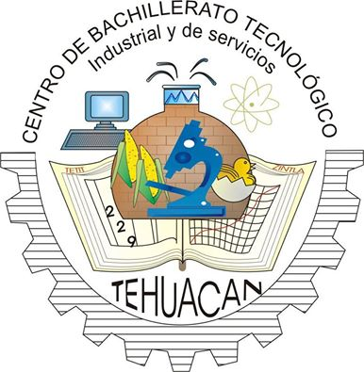


PROJECT NAME
Eco-recycling

NAME OF THE MEMBERS
DAVID SORIANO GOMEZ
MARIFER RUIZ ALAMILLO
GERALDINE JIMENEZ CRUZ
KAROL ITZEL GUZMAN JUAREZ
ANA BELÉN MÉNDEZ SÁNCHEZ
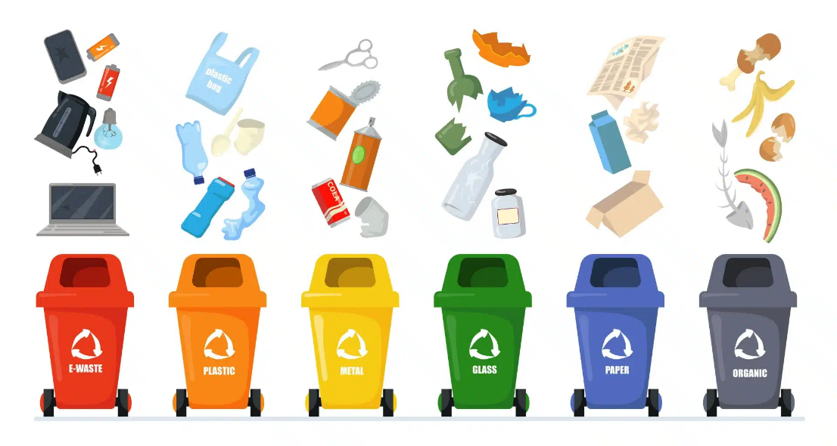

INTRODUCTION
The purpose of this technical manual is to document in detail the development, operation, architecture and structure of the EcoReciclaje mobile application, developed in Android Studio as part of the final project of the programming specialty.
The EcoReciclaje application was designed with the aim of promoting recycling and optimizing waste management through the use of technological tools. Its main purpose is to allow users to identify, register and manage recyclable materials efficiently, especially within a school environment, taking CBTis 229 in Tehuacán, Puebla as a central collection point.
The system was developed using modern mobile development technologies, achieving a functional, intuitive and scalable application. Among the main tools used are Android Studio, Kotlin, XML, Firebase, Google Cloud Platform and local databases through Room Database, as well as integrations with services such as Google Maps API and Firebase Cloud Messaging.
EcoReciclaje integrates various modules that allow us to offer a complete user experience. Among its main functionalities are:
User authentication system using Firebase Authentication.
*User authentication system.
*Registration and sign-in using Firebase Authentication.
* Recyclable materials inventory system.
*QR code scanner and generator.
*Smart collection system.
*Maps module using Google Maps.
*Official location of CBTis 229 as a recycling center.
*System of ecological eco-points.
*User profile management.
*Push notifications using Firebase Cloud Messaging.
*Local database using Room Database.
*Design based on Material Design.
*Modular navigation between Activities.
*Integration with Google Cloud Platform.
The application allows automating processes related to recycling, facilitating the control and monitoring of materials, as well as promoting the active participation of users in ecological activities.
In terms of the technical structure, the system has an organized architecture that includes the management of interfaces, business logic, data storage and communication with cloud services. In addition, the use of Gradle for dependency management and GitHub for project version control was implemented.
This manual contains detailed technical information on:
- General system architecture.
- Internal structure of the project.
- Firebase settings.
- Google Cloud setup.
- Google Maps settings.
- Dependencies used.
- Gradle configuration.
- Operation of modules.
- Navigation system.
- Interface design.
- Structure of Activities.
- QR operation.
- Database.
- Operating flow.
- AndroidManifest settings.
- API integration.
- Installation and maintenance.

The main objective of this document is to facilitate the technical understanding of the system, as well as to support future tasks of maintenance, improvement and expansion of the EcoReciclaje application, both for developers and users with technical knowledge.

General Objective
Develop a smart mobile application focused on caring for the environment by automating the registration, control and management of recyclable waste using modern mobile technologies and cloud services

Specific Objectives
- Implement a QR scanning system to identify and register recycling bins.
- Design an inventory module to control recyclable materials.
- Develop an interactive map to locate nearby collection centers.
- Create a system of eco-points to encourage recycling.
- Record and control the collections made daily.
- Store information in a SQL Server database for better system management.

System Overview

EcoRecycling is a mobile application developed for Android devices aimed at the digital control and management of recyclable waste within a school environment.
The app allows users to perform different recycling-related actions using smart tools.
Among the main actions that the user can perform are:
*Log in.
*Register.
*Check the inventory.
*Scan QR codes.
*Generate QR codes.
* View the recycling center.
*Consult ecological information.
*Request pickups.
* View eco-points.
*Check their profile.
*Receive notifications.
The application was designed using a modular architecture based mainly on independent Activities connected by Intents.
The system uses cloud services provided by Firebase and Google Cloud Platform to provide authentication, mapping services, and notifications.

System Requirements

Hardware Requirements
- Intel Core i3 processor or higher.
- 4 GB RAM minimum.
- 10 GB of free space.
- Physical Android device.
- Functional camera.
- Built-in GPS.
- Internet connection.

Software Requirements
- Android Studio instalado.
- JDK 17.
- Updated Android SDK.
- Gradle configured.
- Firebase configured.
- Google Services instalado.
- Android emulator or physical phone.
- Google Play Services.

System Architecture

The application uses a modular architecture based on independent Activities connected by internal navigation using Intents.
The architecture allows the main functionalities of the system to be kept separate to facilitate maintenance and future expansions.

Users Module
It allows registration, login, and management of users within the application.

QR Scanner Module
It allows QR codes to be read to record information from recycling cans and associate data such as weight and type of material.

Inventory Module
Manages the control of recyclable waste stored within the system.

Collection Module
Manage waste collection requests and records.

Maps Module
It uses GPS to show collection centers close to the user.

Eco-Points Module
It allows you to accumulate points for recycling activities carried out by users.

General System Operation
- The user signs in to the app.
- Go to the main menu.
- Scan a QR code associated with a recycling bin.
- The system records material information.
- The data is stored in the database.
- The user receives eco-points for the activity carried out.
- The information can be consulted later in the inventory module.

Conclusion
The EcoReciclaje application represents a technological solution focused on promoting the culture of recycling and environmental care through the use of accessible digital tools.
The development of the project allowed the application of knowledge of mobile programming, databases, interface design and information management, managing to create a functional application aimed at solving a current environmental problem.
Thanks to its different modules, EcoReciclaje facilitates the registration, control and management of recyclable waste, in addition to encouraging user participation through a system of eco-points and interactive tools.

